EMS - 17
(15/Oct/24, Rev0)

Environmental Management System (EMS) Logs

M.V./M.T

Port of Registry

IMO No.

 |  | INDEX
Rev 0 | Section 1 | Line Break & Leakage Log
Rev 0 | Section 2 | Oil to Sea Interface Log
Rev 0 | Section 3 | Daily Sewage Log
Rev 0 | Section 4 | Hazardous Wastes Manifest

INTRODUCTION & INSTRUCTIONS

Line Breaks & Leakage Log

The Line Break & Leakage Log has been introduced in order to have a standard system for monitoring the failure of any line or component in the engine room and machinery spaces on a fuel oil, lube oil, waste oil, sea water, fresh water, condensate, or cooling water system including any release due to an operational error. The log shall include leaks or failures of high pressure lines on diesel engines.

Oil to Sea Interface Log

The oil to sea interface log has been introduced in order to have a standard system for monitoring equipment having oil-to-sea interfaces. Such interfaces may include oil lubricated stern tubes, bow or stern thrusters, stabilizers, hydraulically operated controllable pitch propellers, Rudder Carrier Bearings, Sea Water cooled Systems such as Lube oil coolers or hydraulic power packs, hydraulically operated ballast tank valves and similar equipment whereby the leakage of a sealing component may cause a loss of operating medium into the surrounding waters of the vessel. Replenishment of oil into the head tanks, operating systems reservoirs, or other receivers associated with this equipment shall be logged regardless of quantity. Ingress of water or drainage of water into or from these systems must also be logged.

When known, an explanation of the loss shall be provided, along with date, time, and signature. ANY oil loss must be recorded in this log book and reported immediately to the Company. Any oil loss overboard must additionally be recorded in the Oil Record Book Part 1 under Code G and appropriate action must be carried out such as but not limited to lowering the level of the header tank.

If any Chief Engineer or other engine room staff fails to promptly and accurately report these conditions, the company will investigate and take appropriate action, which may include termination of employment.

Daily Sewage Log

This log has been introduced in order to record the daily check of the chlorine tablets, quantity of chlorine tablets added, result of test for the chlorine content in the STP effluent, and date of backflushing. If chlorine is used as a disinfectant, ensure that the residual Chlorine in the effluent is kept below 0.5 mg/l. (1 ppm = 1 mg/l)

Hazardous Waste Manifest

This log has been introduced in order to record the location and quantity of various hazardous wastes on board. This log is to be completed every month.


SECTION 1 - LINE BREAKS & LEAKAGE LOG

Date | Identification of Leaking Line / Component | Reason for the Leak | Action taken to rectify the Leak | Released Fluid |  |  |  | Remarks | C/E signature
 |  |  |  | Description of Fluid  (FO/DO/MECC/MECLY/ AECC/WO/SW/FW/  condensate etc) | Quantity | Handling of the released fluid |  | Remarks | C/E signature
 |  |  |  |  |  | Tank transferred to | If not transferred how disposed | Remarks | C/E signature
2-Mar-13 | FO line from FO settling tank to purifier | Gasket ruptured from a flange near the purifier platform | Gasket was renewed | Fuel Oil | 2 ltrs | BSOT | NA | NIL | XXXX
4-Mar-13 | SW service pump | Damaged seal | Seal was renewed | Sea Water | 50 ltrs | Evaporation tank | NA | NIL | XXXX
7-Mar-13 | High pressure pipe to forward injector of M/E unit no 4 | Damaged high pressure pipe sealing face | High pressure pipe was renewed | Fuel Oil | 20 ltrs | NA | Cleaned with rags & saw dust which was incinerated. | Incineration has been recorded in the Garbage Record Book. | XXXX
8-Mar-13 | No. 1 M/E LO Pump | Minor leak from gland | Leak monitored | MECC | Trace | NA | Wiped. | Leak to be monitored and cleaned as required | XXXX
8-Mar-13 | Leak from top of Bow Thruster seal. | Minor leak from seal | Leak monitored | Lube Oil | 20 ml | NA | Wiped with rags which was stored in the Oily rags bin for incineration. | Leak to be monitored and cleaned as required | XXXX
9-Mar-13 | Stbd windlass control lever | leak from seal | Leak monitored. | Lube Oil | 50 ml | NA | Wiped with rags which was stored in the Oily rags bin for incineration. | Leak to be monitored and cleaned as required. Seal to be renewed at the next available  opportunity. | XXXX

Date | Identification of Leaking Line / Component | Reason for the Leak | Action taken to rectify the Leak | Released Fluid |  |  |  | Remarks | C/E signature
 |  |  |  | Description of Fluid  (FO/DO/MECC/MECLY/ AECC/WO/SW/FW/  condensate etc) | Quantity | Handling of the released fluid |  | Remarks | C/E signature
 |  |  |  |  |  | Tank transferred to | If not transferred how disposed | Remarks | C/E signature

Date | Identification of Leaking Line / Component | Reason for the Leak | Action taken to rectify the Leak | Released Fluid |  |  |  | Remarks | C/E signature
 |  |  |  | Description of Fluid  (FO/DO/MECC/MECLY/ AECC/WO/SW/FW/  condensate etc) | Quantity | Handling of the released fluid |  | Remarks | C/E signature
 |  |  |  |  |  | Tank transferred to | If not transferred how disposed | Remarks | C/E signature

Notes:
- Identification of Leaking Line / Component means a description of any line or component on a fuel, lube, waste oil, sea water, fresh water, condensate, or cooling water system that has leaked including any release due to an operational error.
- Handling of the released fluid means an explanation of where / to which tank the released fluid was transferred or

The above entries shall be made and signed by the Chief Engineer.

SECTION 2 - OIL TO SEA INTERFACE LOG

4:05 20 ltrs YES / NO* Within/outside* Leaking Stern
ship Tube fwd seal NA NA NA - - - - - -
0:30 - YES / NO* Within/outside* Within/outside Damaged gasket.
ship - - - - Bow Thruster 20 ltrs YES / NO* * ship Same renewed NA N

9:36 Nil YES / NO* Within/outside*
ship NA NA 10 ltrs Water drained from aft seal pot - - - - - -
Header tank level lowered, Entry
1:10 Nil YES / NO* Within/outside* Leaking Stern
ship Tube aft seal NA NA made in the ORB Code G & the - - - - - -
Company informed.

5:45 - YES / NO* Within/outside* Within/outside Damaged gasket.
ship - - - - Bow Thruster Nil YES / NO* * ship Same renewed NA N
Ballast tank Loss of oil from the
1:00 - YES / NO* Within/outside* Within/outside ballast tank
ship - - - - hydraulic 30 ltrs YES / NO* * ship hydraulic valve NA N
valve system operating resovoir.
YES / NO* Within/outside* Within/outside
ship YES / NO* * ship
YES / NO* Within/outside* YES / NO* Within/outside
ship * ship

YES / NO* Within/outside* Within/outside
ship YES / NO* * ship
YES / NO* Within/outside* Within/outside
ship YES / NO* * ship
YES / NO* Within/outside* Within/outside
ship YES / NO* * ship
YES / NO* Within/outside* Within/outside
ship YES / NO* * ship
YES / NO* Within/outside* Within/outside
ship YES / NO* * ship
OIL LUBRICATED STERN TUBE |  |  |  |  |  |  |  |  |  | Bow Thruster / Controlable Pitch Propeller / Rudder Carrier Bearing / SW Cooled Systems / Hydraulically operated ballast tank valves / Other Equipment ( )
Date | Time | OIL |  |  |  |  | WATER |  | Remarks | Name of the equipment | OIL |  |  |  | WATER |  | Remarks | C/E signature
Date | Time | Amount of Oil replenished (Ltrs) | Any visual Leakage observed? | Location of visual oil leakage |  | Reason for oil replenishment  / Loss | Qty of water entered system (Ltrs) | Qty of water drained from system (Ltrs) | Remarks | Name of the equipment | Amount of Oil replenished (Ltrs) | Any visual Leakage observed? | Location of visual oil leakage | Reason for oil replenishment / Loss | Qty of water entered system (Ltrs) | Qty of water drained from system (Ltrs) | Remarks | C/E signature
5-Feb-13 | 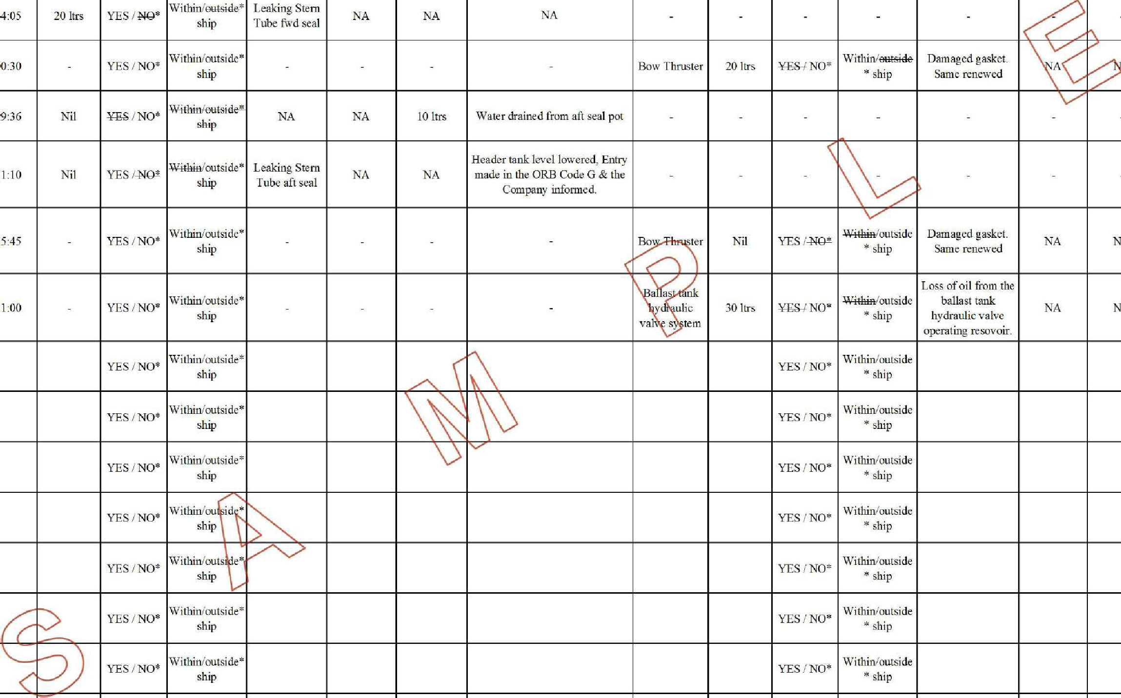  1 |  |  |  |  |  |  |  |  |  |  |  |  |  |  | - | - | XXXX
7-Feb-13 | 1 |  |  |  |  |  |  |  |  |  |  |  |  |  |  | A | Oil cleaned with rags which was incenerated & recorded in the Garbage Record Book. | XXXX
8-Feb-13 | 0 |  |  |  |  |  |  |  |  |  |  |  |  |  |  | - | - | XXXX
4-Mar-13 | 1 |  |  |  |  |  |  |  |  |  |  |  |  |  |  | - | - | XXXX
6-Mar-13 | 1 |  |  |  |  |  |  |  |  |  |  |  |  |  |  | A | Header tank level lowered, Entry made in ORB Code G & the company informed. | XXXX
10-Mar-13 | 1 |  |  |  |  |  |  |  |  |  |  |  |  |  |  | A | Suspect No. 3 WBT v/v leak. v/v isolated, entry made in ORB Code G & the company informed. | XXXX
 |  |  | YES / NO* | Within/outside* ship |  |  |  |  |  |  |  | YES / NO* | Within/outside  * ship

SECTION 2 - OIL TO SEA INTERFACE LOG

OIL LUBRICATED STERN TUBE |  |  |  |  |  |  |  |  | Bow Thruster / Controlable Pitch Propeller / Rudder Carrier Bearing / SW Cooled Systems / Hydraulically operated ballast tank valves / Other Equipment ( )
Date | Time | OIL |  |  |  | WATER |  | Remarks | Name of the equipment | OIL |  |  |  | WATER |  | Remarks | C/E signature
Date | Time | Amount of Oil replenished (Ltrs) | Any visual Leakage observed? | Location of visual oil leakage | Reason for oil replenishment  / Loss | Qty of water entered system (Ltrs) | Qty of water drained from system (Ltrs) | Remarks | Name of the equipment | Amount of Oil replenished (Ltrs) | Any visual Leakage observed? | Location of visual oil leakage | Reason for oil replenishment / Loss | Qty of water entered system (Ltrs) | Qty of water drained from system (Ltrs) | Remarks | C/E signature
 |  |  | YES / NO* | Within/outside* ship |  |  |  |  |  |  | YES / NO* | Within/outside  * ship
 |  |  | YES / NO* | Within/outside* ship |  |  |  |  |  |  | YES / NO* | Within/outside  * ship
 |  |  | YES / NO* | Within/outside* ship |  |  |  |  |  |  | YES / NO* | Within/outside  * ship
 |  |  | YES / NO* | Within/outside* ship |  |  |  |  |  |  | YES / NO* | Within/outside  * ship
 |  |  | YES / NO* | Within/outside* ship |  |  |  |  |  |  | YES / NO* | Within/outside  * ship
 |  |  | YES / NO* | Within/outside* ship |  |  |  |  |  |  | YES / NO* | Within/outside  * ship
 |  |  | YES / NO* | Within/outside* ship |  |  |  |  |  |  | YES / NO* | Within/outside  * ship
 |  |  | YES / NO* | Within/outside* ship |  |  |  |  |  |  | YES / NO* | Within/outside  * ship
 |  |  | YES / NO* | Within/outside* ship |  |  |  |  |  |  | YES / NO* | Within/outside  * ship
 |  |  | YES / NO* | Within/outside* ship |  |  |  |  |  |  | YES / NO* | Within/outside  * ship
 |  |  | YES / NO* | Within/outside* ship |  |  |  |  |  |  | YES / NO* | Within/outside  * ship
 |  |  | YES / NO* | Within/outside* ship |  |  |  |  |  |  | YES / NO* | Within/outside  * ship
 |  |  | YES / NO* | Within/outside* ship |  |  |  |  |  |  | YES / NO* | Within/outside  * ship
 |  |  | YES / NO* | Within/outside* ship |  |  |  |  |  |  | YES / NO* | Within/outside  * ship
 |  |  | YES / NO* | Within/outside* ship |  |  |  |  |  |  | YES / NO* | Within/outside  * ship

SECTION 2 - OIL TO SEA INTERFACE LOG

OIL LUBRICATED STERN TUBE |  |  |  |  |  |  |  |  | Bow Thruster / Controlable Pitch Propeller / Rudder Carrier Bearing / SW Cooled Systems / Hydraulically operated ballast tank valves / Other Equipment ( )
Date | Time | OIL |  |  |  | WATER |  | Remarks | Name of the equipment | OIL |  |  |  | WATER |  | Remarks | C/E signature
Date | Time | Amount of Oil replenished (Ltrs) | Any visual Leakage observed? | Location of visual oil leakage | Reason for oil replenishment  / Loss | Qty of water entered system (Ltrs) | Qty of water drained from system (Ltrs) | Remarks | Name of the equipment | Amount of Oil replenished (Ltrs) | Any visual Leakage observed? | Location of visual oil leakage | Reason for oil replenishment / Loss | Qty of water entered system (Ltrs) | Qty of water drained from system (Ltrs) | Remarks | C/E signature
 |  |  | YES / NO* | Within/outside* ship |  |  |  |  |  |  | YES / NO* | Within/outside  * ship
 |  |  | YES / NO* | Within/outside* ship |  |  |  |  |  |  | YES / NO* | Within/outside  * ship
 |  |  | YES / NO* | Within/outside* ship |  |  |  |  |  |  | YES / NO* | Within/outside  * ship
 |  |  | YES / NO* | Within/outside* ship |  |  |  |  |  |  | YES / NO* | Within/outside  * ship
 |  |  | YES / NO* | Within/outside* ship |  |  |  |  |  |  | YES / NO* | Within/outside  * ship
 |  |  | YES / NO* | Within/outside* ship |  |  |  |  |  |  | YES / NO* | Within/outside  * ship
 |  |  | YES / NO* | Within/outside* ship |  |  |  |  |  |  | YES / NO* | Within/outside  * ship
 |  |  | YES / NO* | Within/outside* ship |  |  |  |  |  |  | YES / NO* | Within/outside  * ship
 |  |  | YES / NO* | Within/outside* ship |  |  |  |  |  |  | YES / NO* | Within/outside  * ship
 |  |  | YES / NO* | Within/outside* ship |  |  |  |  |  |  | YES / NO* | Within/outside  * ship
 |  |  | YES / NO* | Within/outside* ship |  |  |  |  |  |  | YES / NO* | Within/outside  * ship
 |  |  | YES / NO* | Within/outside* ship |  |  |  |  |  |  | YES / NO* | Within/outside  * ship
 |  |  | YES / NO* | Within/outside* ship |  |  |  |  |  |  | YES / NO* | Within/outside  * ship
 |  |  | YES / NO* | Within/outside* ship |  |  |  |  |  |  | YES / NO* | Within/outside  * ship
 |  |  | YES / NO* | Within/outside* ship |  |  |  |  |  |  | YES / NO* | Within/outside  * ship

SECTION 3 - DAILY SEWAGE LOG

Date | Was daily check of chlorine tablets carried out? | Quantity  of chlorine tablets added (as required) | Result of test for the chlorine content in the STP effluent | Date of last backflush | Duty Engineer's Sign
1-Mar-13 | Yes | NA | 5 ppm | 1-Feb-13 | xxx
2-Mar-13 | Yes | NA | - | 1-Feb-13 | xxx
3-Mar-13 | Yes | NA | - | 1-Feb-13 | xxx
4-Mar-13 | Yes | 6 tablets | - | 1-Feb-13 | xxx
5-Mar-13 | Yes | NA | - | 1-Feb-13 | xxx
6-Mar-13 | Yes | NA | - | 1-Feb-13 | xxx
7-Mar-13 | Yes | NA | 5 ppm | 1-Feb-13 | xxx

SECTION 3 - DAILY SEWAGE LOG

Date | Was daily check of chlorine tablets carried out? | Quantity  of chlorine tablets added (as required) | Result of test for the chlorine content in the STP effluent | Date of last backflush | Duty Engineer's Sign

SECTION 3 - DAILY SEWAGE LOG

Date | Was daily check of chlorine tablets carried out? | Quantity  of chlorine tablets added (as required) | Result of test for the chlorine content in the STP effluent | Date of last backflush | Duty Engineer's Sign

SECTION 4 - HAZARDOUS WASTE MANIFEST

Vessel:
Year:
Port:

S. No | Description of Hazardous Waste | Location of storage on board | Quantity in Cu. M or in number as applicable
S. No | Description of Hazardous Waste | Location of storage on board | Jan | Feb | Mar | Apr | May | Jun | Jul | Aug | Sep | Oct | Nov | Dec
1 | Used solvents
2 | Used Degreasers
3 | Used Cleaning Wastes
4 | Expired Boiler and Engine Chemicals
5 | Used Boiler and Engine Chemicals
6 | Contaminated Refrigerants
7 | Unusable Paints
8 | Contaminated Bunkers
9 | Used Fluorescent and Incandescent Bulbs
10 | Expired / Used Batteries
11 | Expired Pyrotechnics
12 | EPIRB - record ID Nos of each expired / defective EPIRB
13 | Used / Expired Gas detection tubes (draeger tubes, etc)
14 | Old electronic parts (Printed Circuit Boards, fire detector heads, etc)
15 | Any garbage containing more than traces of heavy metals
16 | Material containing Asbestos (if available on board)
17 | Expired Medicines
18 | Expired controlled drugs
19 | Used Syringes, Scalpels etc
20 | Incinerator Ash
21 | Empty Cargo sample / FO and LO sample bottles
22 | Empty LO drums
23 | Empty Paint drums
24 | Empty span gas bottles / Used Aerosol cans
Chief Engineer's Signature
Master Signature

Note: All disposal of hazardous waste must be recorded in the Garbage Record Book as per instructions.

